**Aggregate Demand (Inflation, spending and output)**

* Higher inflation reduces the purchasing power of financial assets, and this reduction of real wealth tends to reduce household spending.
* High inflation tends to redistribute resources from less well-off household, who spend greater proportions of their incomes, to better off households, who spend a lesser proportion. Thus overall spending is reduced.
* Higher inflation generates uncertainty for households and firms and this makes them more cautious and reduces their spending.
* At constant exchange rates, higher domestic inflation makes exports less competitive, and reduces the level of net exports. Again, this reduces spending at higher levels of inflation.
* Most importantly, when the inflation rate exceeds its targeted level, the Reserve Bank will increase interest rates, which reduces consumption and investment.
* Recall from the Keynesian model that the short-run equilibrium level of output equals planned aggregate expenditure. Therefore, lower aggregate expenditure due to inflation implies lower equilibrium level of output.
* That is, from the demand (or expenditure) side, there is a negative relationship between inflation and output.

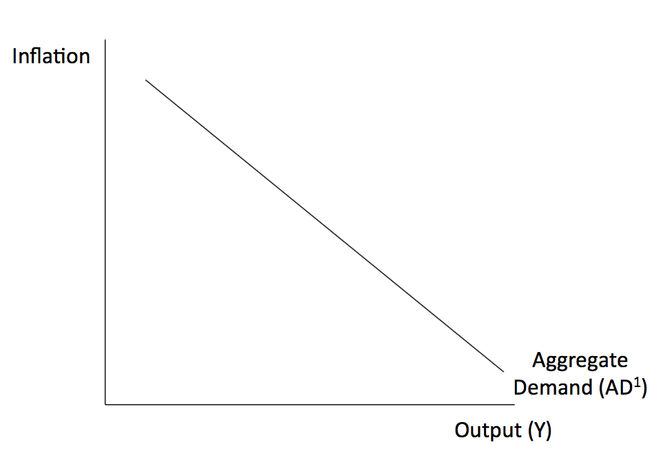

* Because increases in inflation reduce planned spending and short-run equilibrium output, the AD curve is downward-sloping.
* The points on the AD Curve show how the short-run equilibrium between PAE and Actual Y changes as inflation changes.

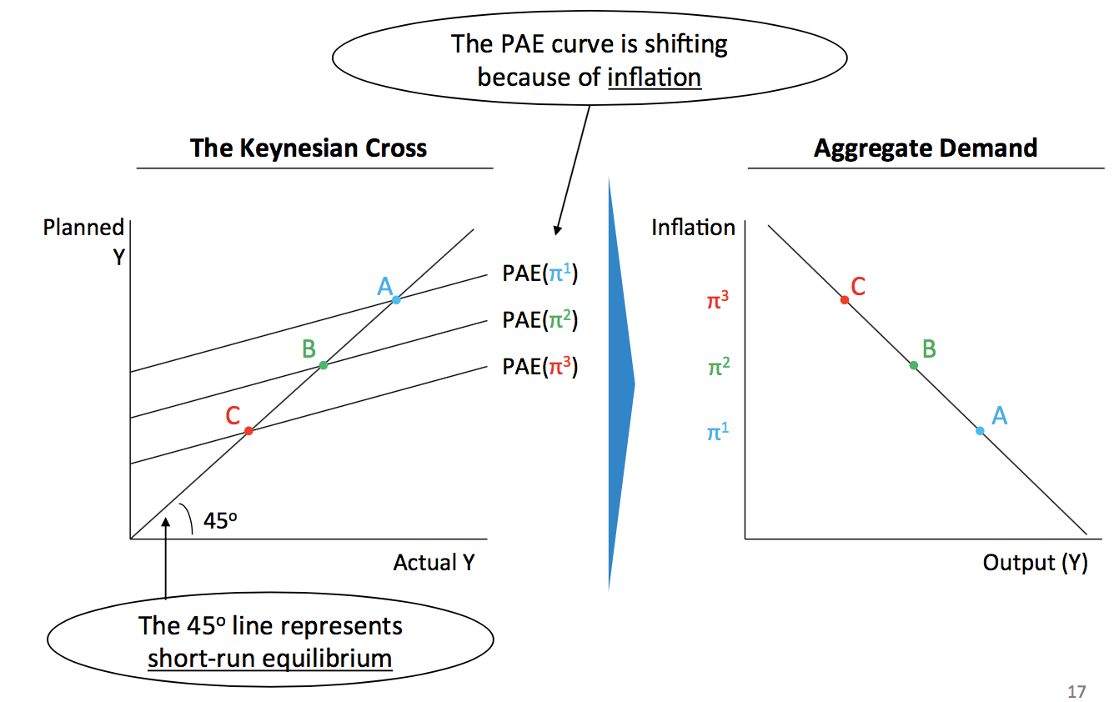

High inflation causes the PAE curve to shift down, and therefore the AD to slope downwards.

* Reasons for the PAE curve to shift down and AD to slope downward:

1. Monetary policy: If inflation exceeds its target, the Central Bank will raise real interest rate, reducing C and I, and equilibrium output.
2. Wealth: High inflation reduces the value of future income, reducing C
3. Uncertainty: High inflation creates uncertainty, so households and firms spend less
4. Exports: High inflation (if exchange rate is unchanged) makes exports less competitive, and reduces the level of net exports.
5. High inflation distorts relative prices of goods, reducing aggregate demand.

* A shift in the PAE that is NOT due to inflation (may be other exogenous changes in G, T, C, I, X and r) will also cause the aggregate demand curve to shift:

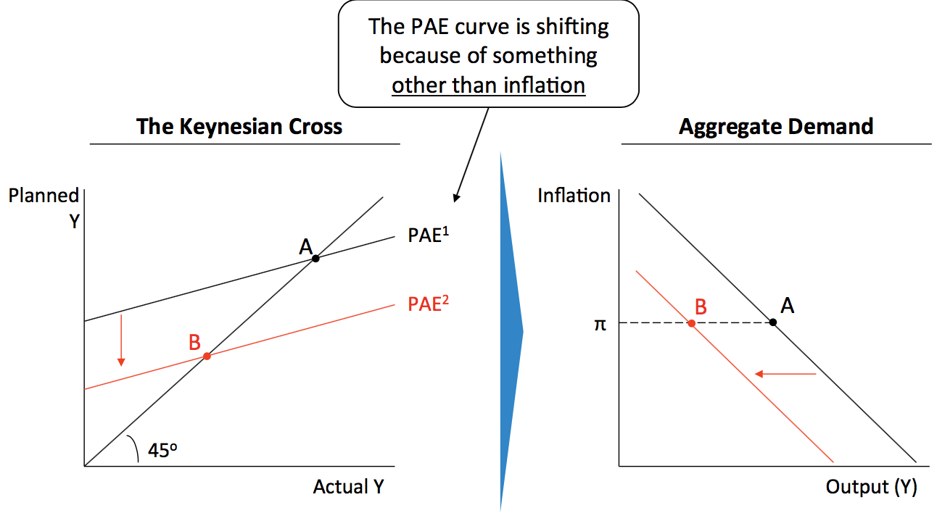

* Changes in spending caused by changes in inflation will lead to movements along the AD: For example: An increase in the inflation rate that leads the Reserve Bank to change the real interest rate will result in a decrease in the short-run equilibrium output --- movement from point A to B
* Any factor that changes the equilibrium level of output at a given level of inflation will shift the AD curve. For example:
* The level of government spending, consumer and business confidence, increased business investment, increases in exports, etc.
* An increase in exogenous spending increases equilibrium output at each level of inflation and the AD curve shifts to the right.
* A change in the Reserve Bank policy reaction function (the Central Bank’s Taylor Rule), ie., in the way the Reserve Bank’s interest rate reacts to inflation and/or output gaps.
* This shift in the policy reaction function would cause the AD curve to shift as a different equilibrium output would result at each inflation rate.

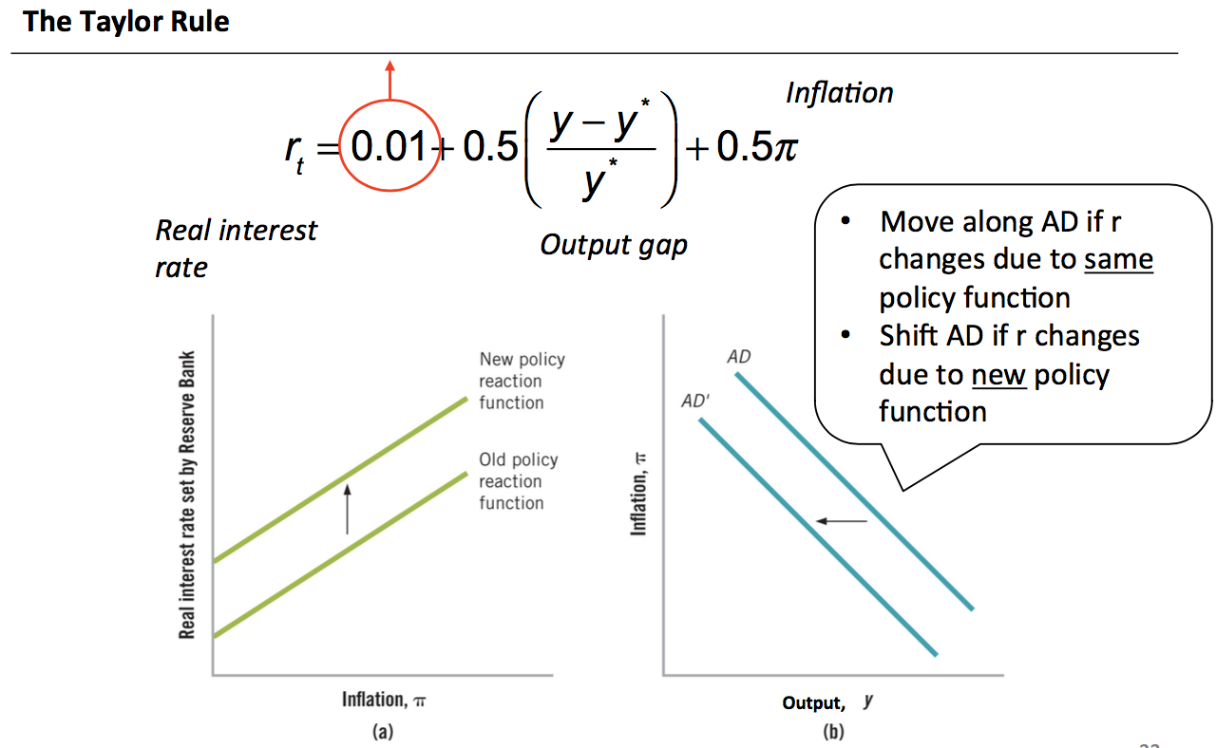

**Aggregate Supply**

* The aggregate supply curve is horizontal in the short term, sloped in the medium term, and vertical in the long term:

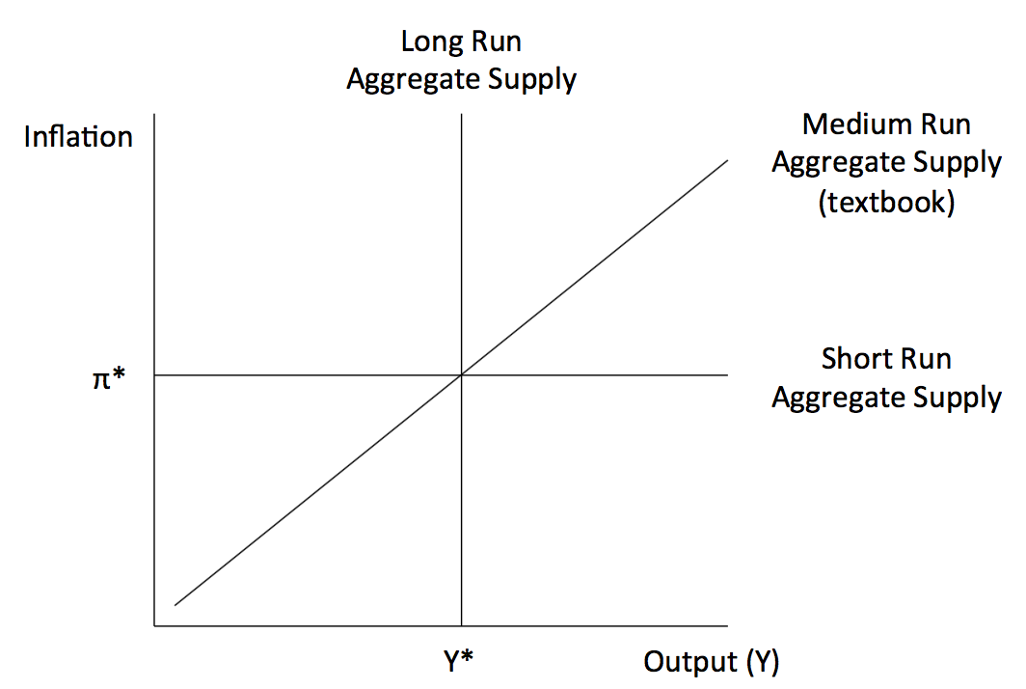

* The slope of the aggregate supply curve changes with the time horizon because prices are initially sticky, but change eventually.

1. In the short run (days-months) prices don’t change because:

* The public expect inflation to be constant.
* Wage and price contracts are already set
* Firms don’t know if a change in demand in “noise” or “signal”

1. In the medium run (quarters – 2years) prices change a little because:

* Inflation expectations remains constant
* Some firms can renegotiate wage and price contracts
* Firms start to think that changes in demand are “signals”

1. In the long run (~>2 years) prices change perfectly because:

* Inflation expectations are fully variable
* All firms can renegotiate wage and price contracts
* All changes in demand are “signals”
* The slow adjustment of inflation is called “inflation inertia”, so central banks work very hard to be “credible” to “anchor” inflation expectations.
* If inflation is inertial, then expected inflation will equal past inflation: 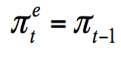
* From the supply or production side, inflation is positively related to the level of output.
* If Y>Y*, most firm’s sales exceed their normal production rates, and firms are likely to increase their price relative to other goods and services. To do so, they will increase their prices by more than their costs increase.
* If all firms behave like this, the inflation rate will tend to increase.
* Similar argument applies to the opposite situation, when Y < Y*
* Only when Y = Y* will the inflation rate tend to remain the same.
* Phillips Curve: The relationship between unemployment / the output gap and inflation

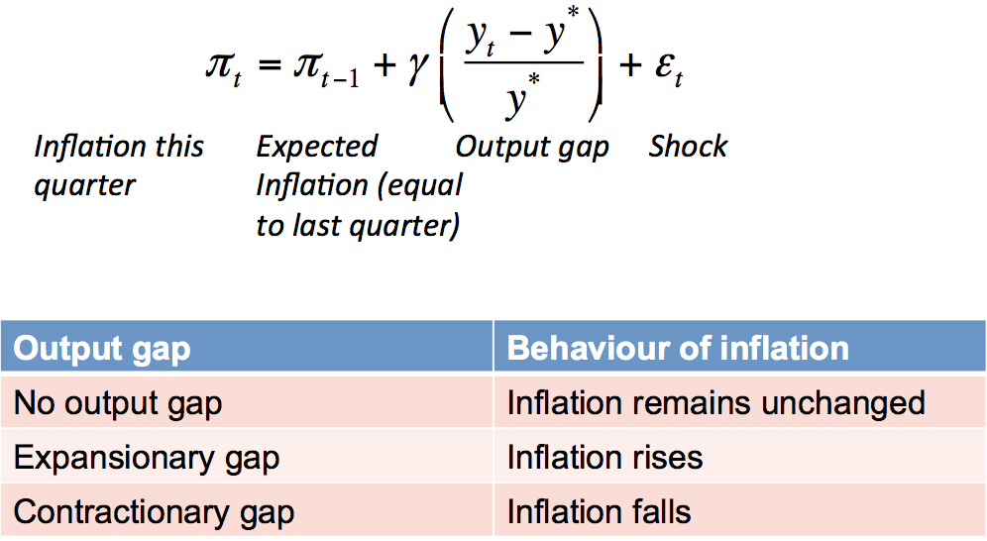

* If output is below long-run potential then inflation will be below expectations:

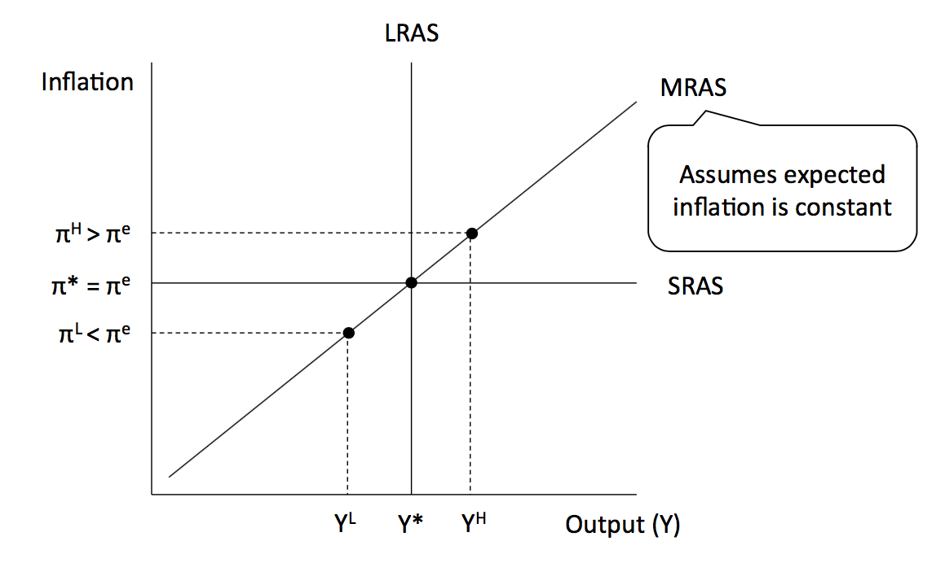

* 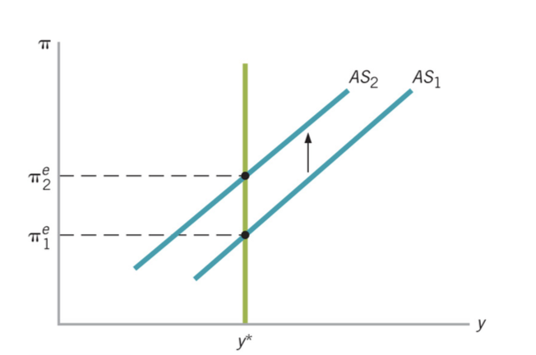If inflation expectations fall, the medium run aggregate supply curve will shift right (increase), and vice versa.
* 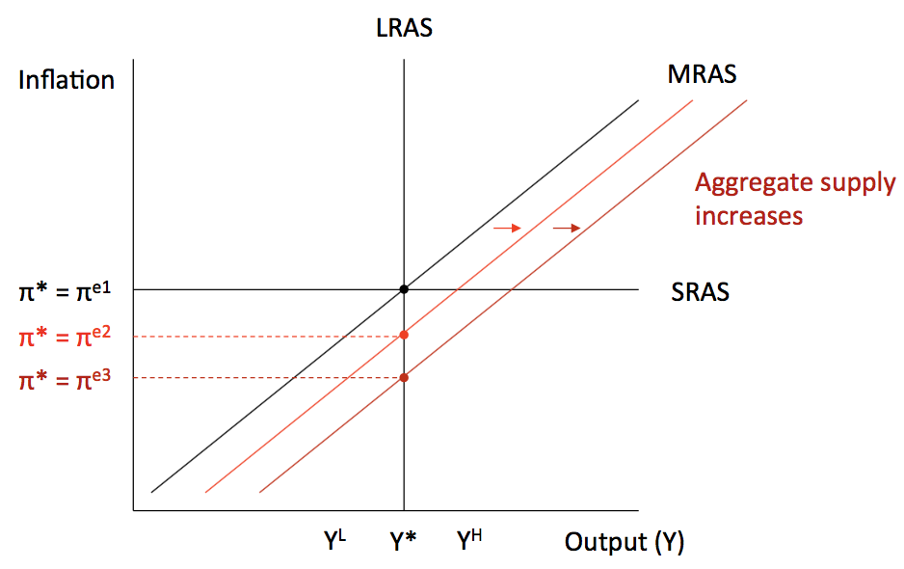An increase in expected inflation from shift the AS curve upward.
* Inflation inertia comes from low inflation causing people to expect low inflation, which then causes low inflation.
* If there is no output gap, then inflation inertia suggests current inflation is equal to expected inflation, which in turn is equal to the previous period’s inflation: 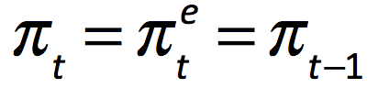
* Otherwise, if there is an expansionary output gap, inflation rises. If there is a contractionary output gap, inflation falls.
* If changes in inflation is due to change in output --- movement along the AS curve
* If increase in AS is due to technological change / increase in unexpected inflation is due to an inflation shock (eg. Because of a rise in oil prices) --- shifts in AS curve:

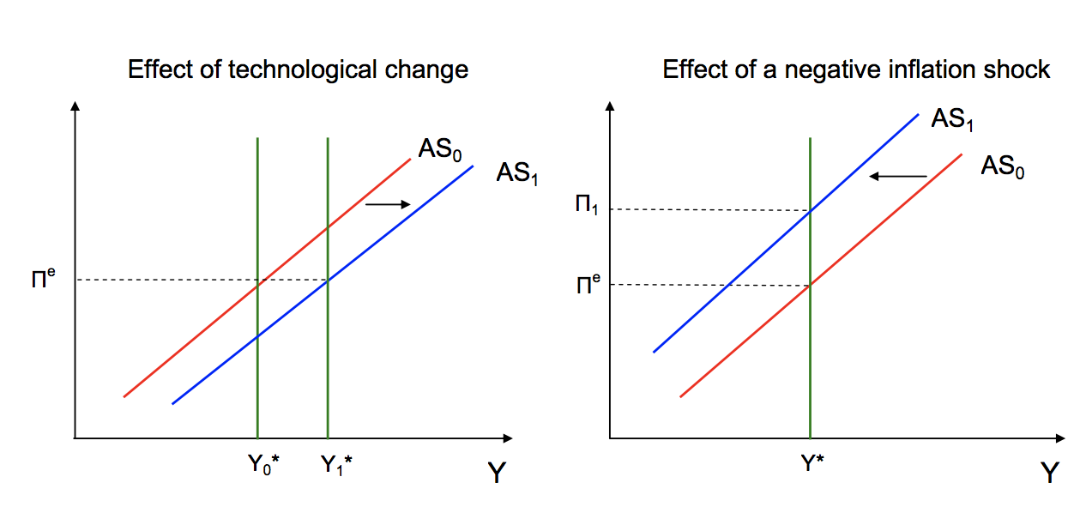

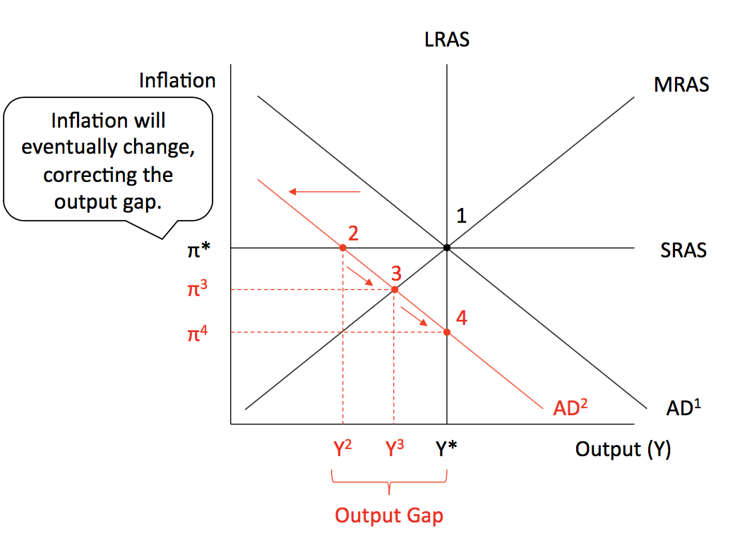**Business Cycles: Shocks to AS and AD**

* A fall in aggregate demand (PAE from the Keynesian Cross) will create an output gap, which will cause inflation to change (from short run 1-2, middle run 1-3 to long run 1-4)
* In the long run, the economy tends to be at potential level of output but, as we saw in the short run, output might be below or above potential level.
* Different reasons for output gaps:
* Demand shocks – factors shifting AD. Ex: Increase in consumer and business confidence resulting in an expansionary output gap
* Supply shocks – affect AS. Ex: Changes in unexpected inflation.
* A positive demand shock and expansionary output gaps:

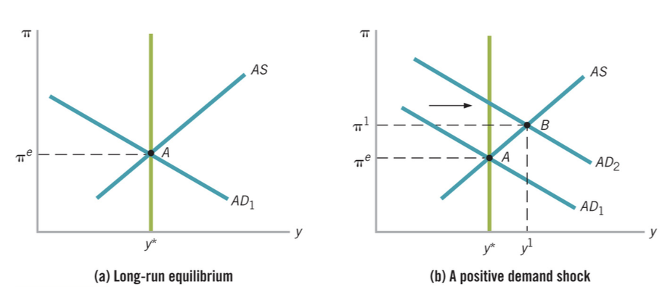

* 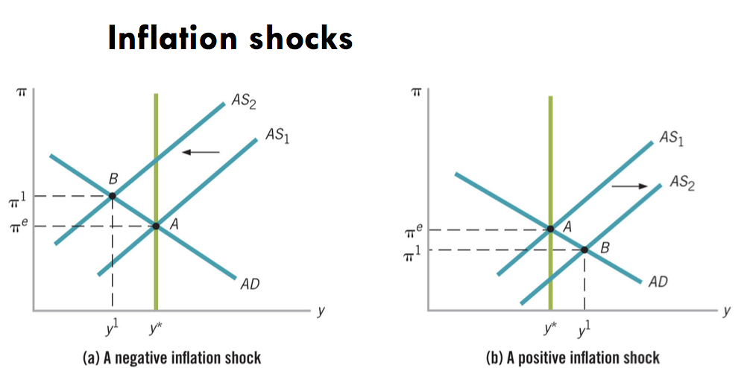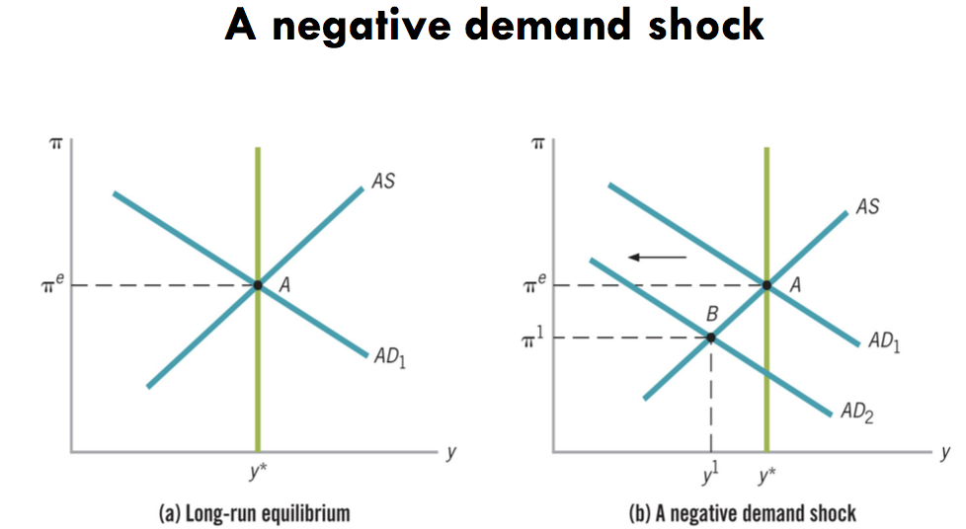A negative demand shocks and contractionary output gaps:
* The self-correcting economy:
* In the long run the economy tends to be at potential level of output because the price level can vary and inflation can rise or fall to bring the economy back to potential level.
* That is: the economy exhibit a self-correcting property in which output gaps can be closed through rising or falling inflation.
* Self-correcting property refers to the fact that output gaps will not last indefinitely, but will be closed by rising or falling inflation.

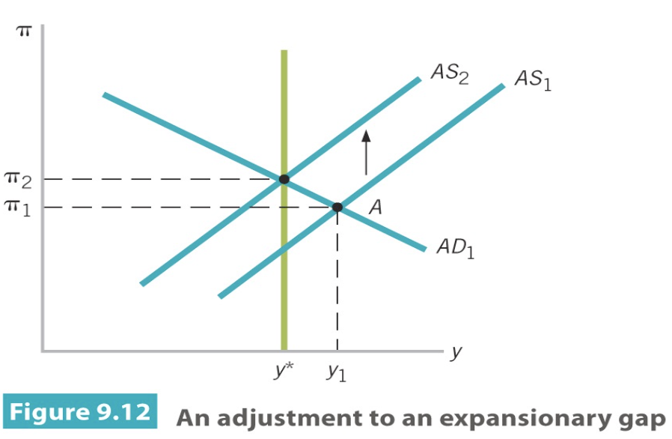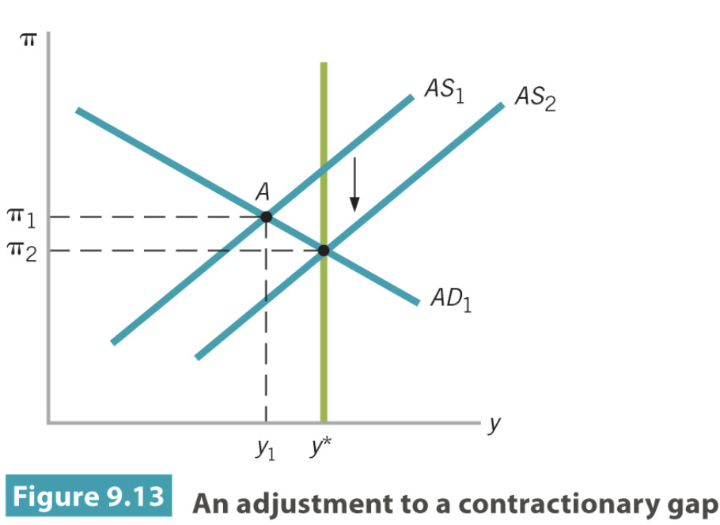

* AD does not change. Long-run equilibrium is restored due to shifts in the AS.
* The role for stabilisation policy:
* If the speed adjustment is fast, then in order to avoid overshooting stabilisation polices should not be pursued.
* However, if the speed of adjustment is slow, then active stabilisation polices should be pursued.
* Example: If there is a drought:
* Fall / shift in the left in medium run aggregate supply to fall. And inflation jump in the medium term.

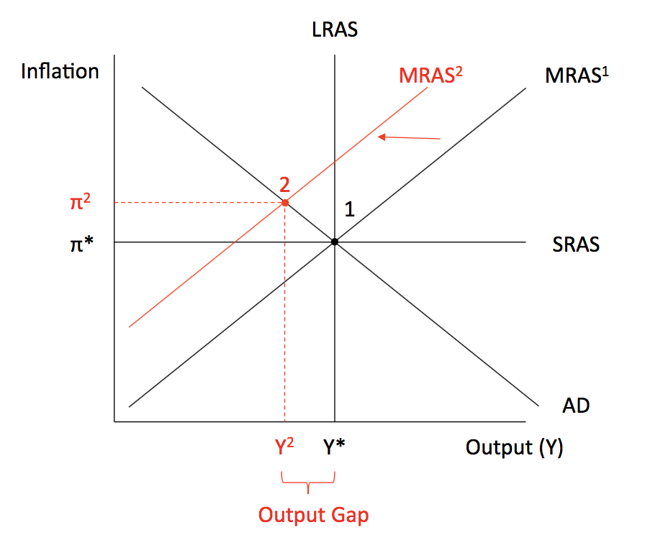

* If the drought ends then aggregate supply will return to where it was:

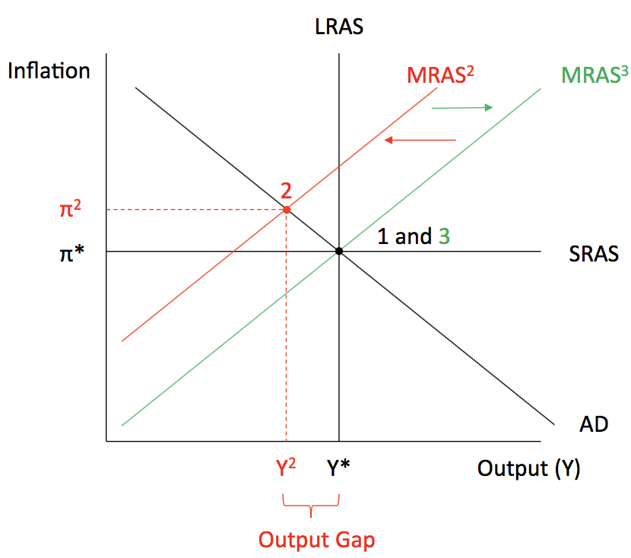

* If the drought becomes permanent (or lasts for years), potential output will change and inflation expectations will update:

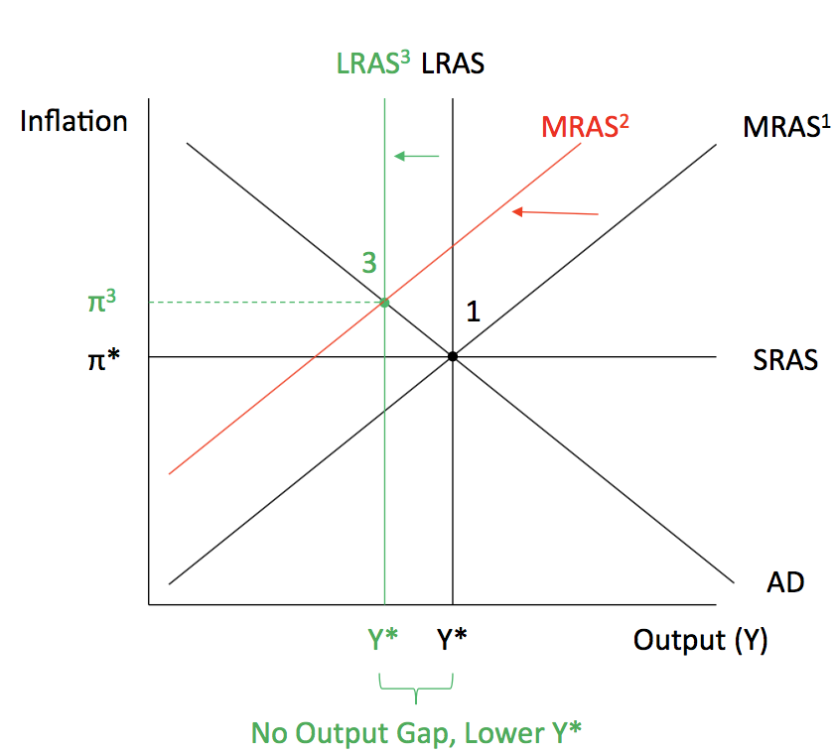

* Movements in aggregate supply also self-correct because of changing inflation expectations.

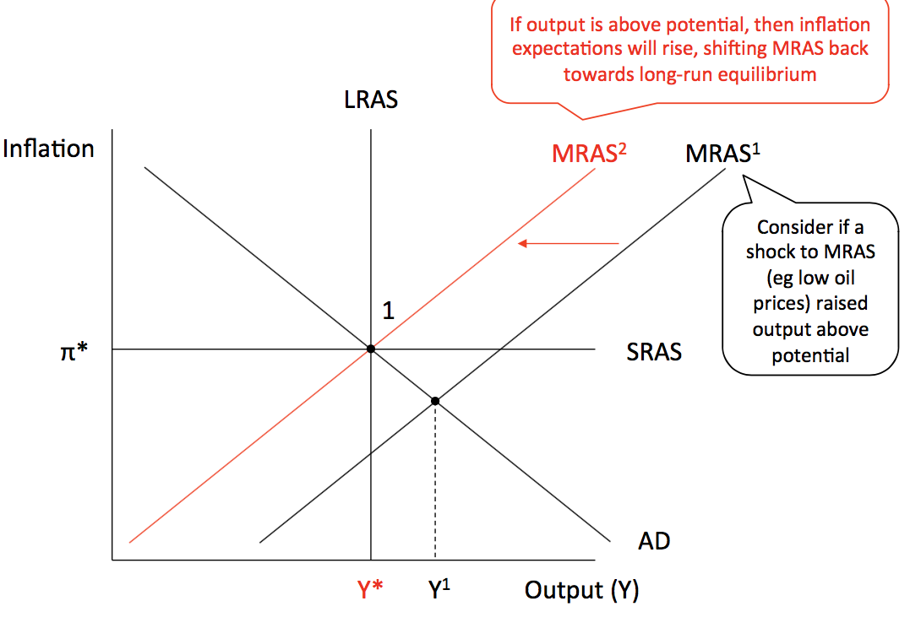MRAS: Medium run aggregate supply

* Potential output (LRAS) is also subject to shocks, like natural disasters, wars, changes in technology and population growth.

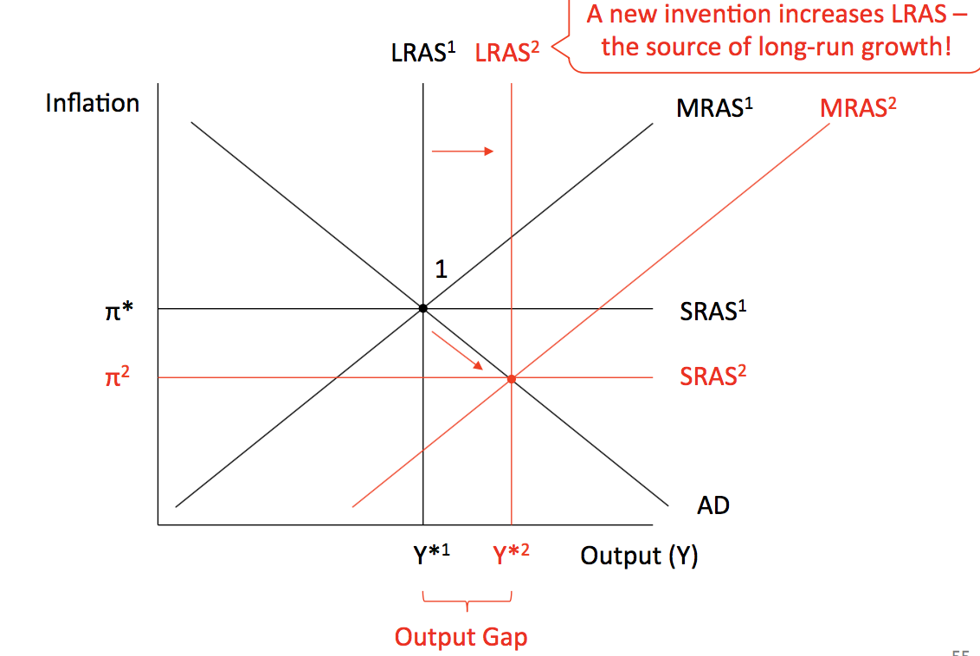

* Movements in LRAS can be used to understand the period of high inflation and low output growth:

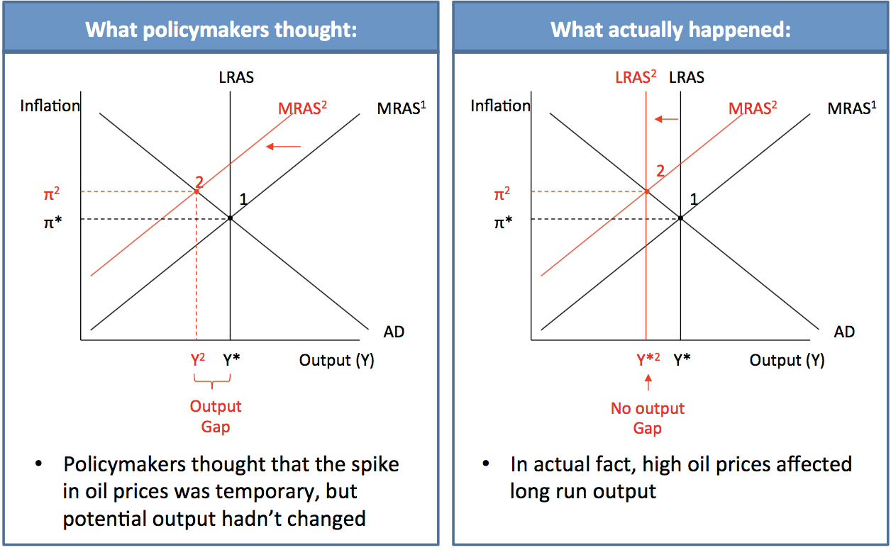

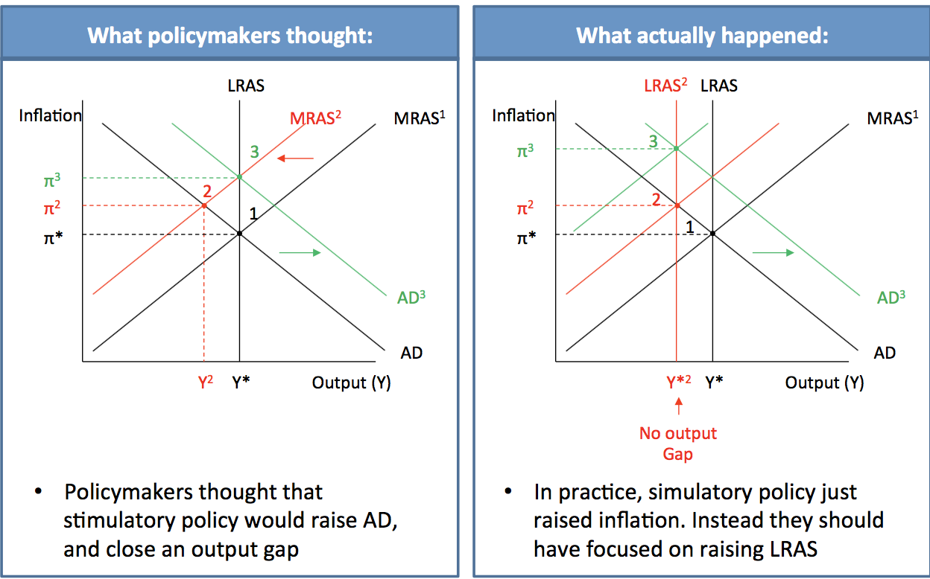

* A tight monetary policy (increase interest rate, decrease level of consumption and level of investment) reduced aggregate demand:

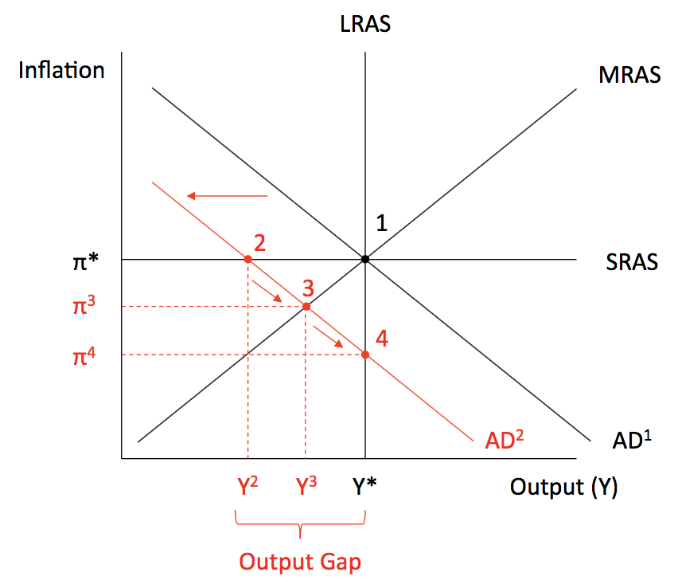

Questions:

1. What does an aggregate demand curve show?
2. What implication do the Reserve Bank’s anti-inflation policies have for the slope of the aggregate demand curve?
3. For what reasons might the aggregate demand curve shift?
4. What is meant by the phrase ‘inflation inertia’?
5. How does the output gap affect the rate of inflation?
6. How is the aggregate demand –aggregate supply diagram constructed?
7. In what sense is the economy ‘self-correcting’?
8. What are the effects on the economy of an inflation shock?
9. Describe how monetary policy can influence the rate of inflation.

Summary:

* The AD-AS diagram has three components: a horizontal SRAS curve, a vertical LRAS curve and a downward-sloping AD curve.
* Short-run equilibrium occurs at the point where the AD curve intersects with the SRAS curve.
* Long-run equilibrium occurs at the point where the AD curve intersects the LRAS curve.
* The economy has the tendency to correct itself back to its long-run equilibrium.
* The AD-AS diagram showcases the dilemma facing the Reserve Bank: the trade-off between inflation and output.
* Disinflation has serious consequences for the economy in the long run.